**Directory Al Imam Mohammad Ibn Saud Islamic University**

**College of Computer and Information Sciences**

**Information Technology Department**

|  |  |
| --- | --- |
| **Course Title:** | Web Systems |
| **Course Code:** | IT 390 |
| **Course Instructor:** | Dr. Amir Mohamed Talib, T. Shatha Alkhaldi,  T. Nora Alghamdi |
| **Assessment:** | Project (phase one) |
| **Semester:** | First 2023 |
| **Due date** | Thursday 29 Sep |
| **6** | 4 grades |

|  |  |
| --- | --- |
| **Group Number** |  |
| **Group Members Name** | **Group Members ID** |
| **Afnan Alswayed** | **441018076** |
| **Sarah Abdullah Alrabiah** | **441021317** |
| **Ahad Altalasi** | **441018171** |
| **Sara Hammoud Alotaibi** | **441019174** |
| **Sara Almutiri** | **441019872** |
| **Section Number** | **372** |

|  |
| --- |
| There will be no extension in the submission deadline.  No late submission will be accepted. |

|  |  |  |
| --- | --- | --- |
| **Official Use Only** | | |
| **Question** | **Student Marks** | **Question Marks** |
| 1 |  | 4 |
| **Total** |  | **4** |

**Phase 1:**



* **Topic:**

There is so many coffee shops and restaurants websites or accounts on different social media platforms but there is not many directories that combines healthy restaurants in Riyadh to help you achieve a healthy lifestyle.

* **Website name:**

**(Behealthy)**

* **Site's goal:**

We aim to create a healthy community to make it easy to reach healthy restaurants.

* **Audience of our site:**

Anyone who is interested in having a healthy eating habits for any age/gender.

* **Competitive analysis**:

The evaluation is a simple check Y/N; (Y=Yes, N=No) or a number from 1 to 10; (1 is the small value, 10 is the big value)

Our competitors are **Foursquare** and **eat** their websites contains all kinds of restaurants what distinguish our website is that we specialize in healthy food.

|  |  |  |  |  |
| --- | --- | --- | --- | --- |
| **Criteria** | | **Foursquare**  *(https://foursquare.com/top-places/riyadh/best-places-healthy-food)* | **Eat**  *(https://eatapp.co/riyadh/restaurant)* | **Addition Functions\Features** |
| **Site Design** | Layout (1-10) | 8 | 9 |  |
| Navigation (1-10)  *+ ( list the global navigation)* | 7 | 9 |
| Look and Feel (1-10) | 5 | 10 |
| **Page**  **Info** | Download Time (1-10) | 4 | 10 |  |
| Page Size (1-10) | 10 | 10 |
| **Features** | Search box in all pages (Y/N) | Yes | Yes | The users are able to view the restaurants on the map. |
| Advanced Search (Y/N)  *+ (list the elements that guide the search)* | Yes  1-Search by area.  2-Search by food type. | Yes  1-Search by cuisines.  2-Search by prices. |
| About Us page (Y/N) | Yes | Yes |
| Contact Us page (Y/N) | Yes | Yes |
| Advertising Allowed (Y/N) | No | Yes |
| Site map page (Y/N) | Yes | No |
| Validated by W3C? (Y/N) | Yes | No |
| **Ease of use** | Effectiveness  (Ability to successfully use a Web site to find information and accomplish tasks.) | 10 | 10 |  |
| Efficiency  (Ability to quickly accomplish tasks with ease and without frustration) | 6 | 10 |
| Satisfaction  (How much a user enjoys using the Web site) | 6 | 10 |

* **Functionalities:**
* **Admin:**

1. The website should allow the admin to a add a new restaurant.
2. The website should allow the admin to delete an existing restaurant.
3. The website should allow the admin to add a logo for the restaurant.
4. The website should allow the admin to edit the restaurant's profile.

* **Visitors:**

1. The website should allow the visitors to rate the restaurants.
2. The website should allow the visitors to add a review.
3. The website should allow the visitors to access the restaurant's profile.
4. The website should allow the visitors to easily navigate through the website pages.
5. The website should allow the visitors to see previous visitor's reviews.

* **Site map:**
* **Required pages**:

1. **Home page:**

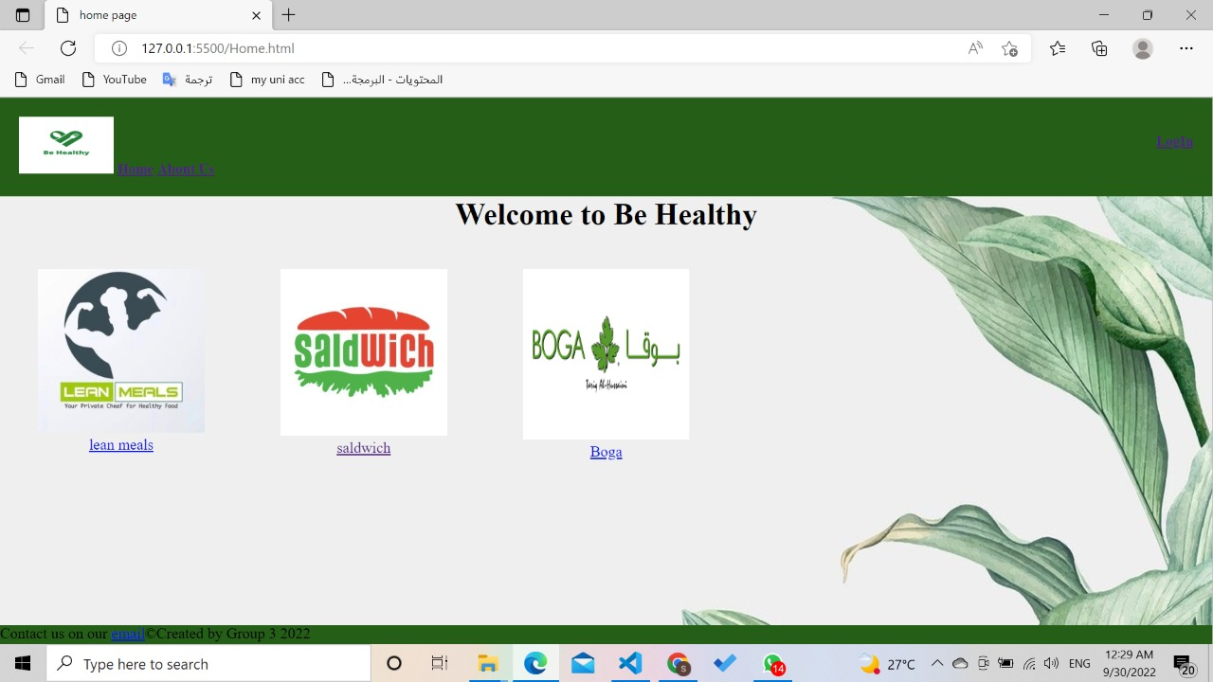

1. **About us page:**

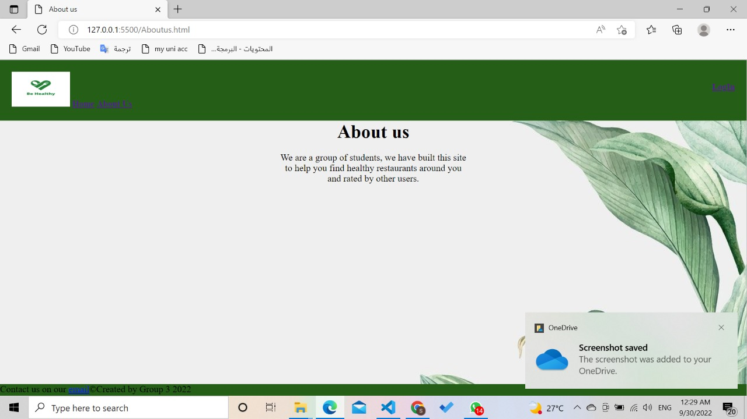

1. **Item profile page:**

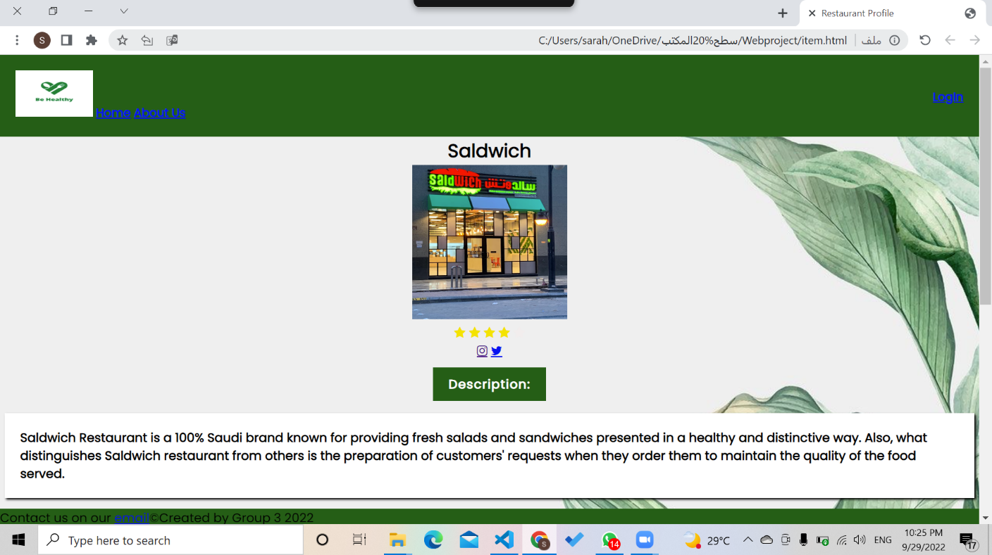

**The description**

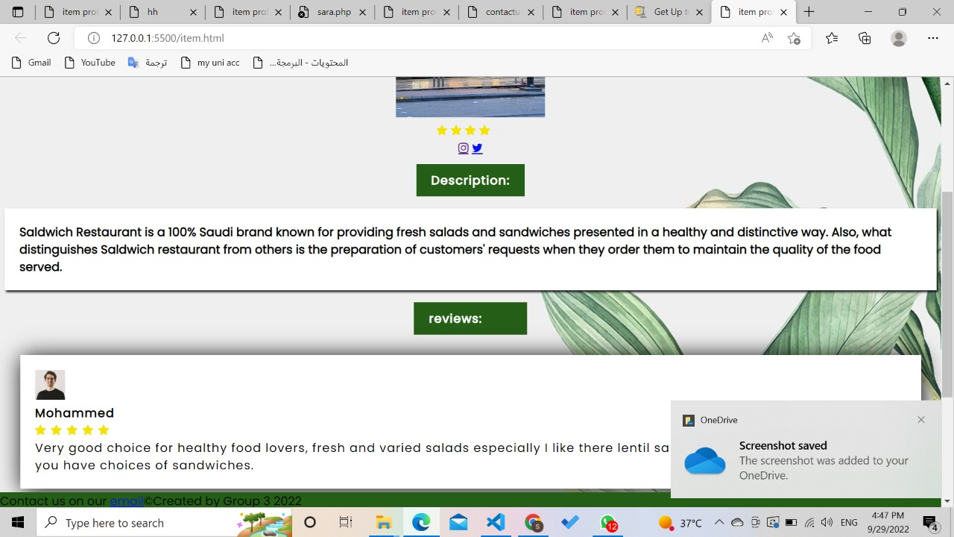

**Previous clients reviews**

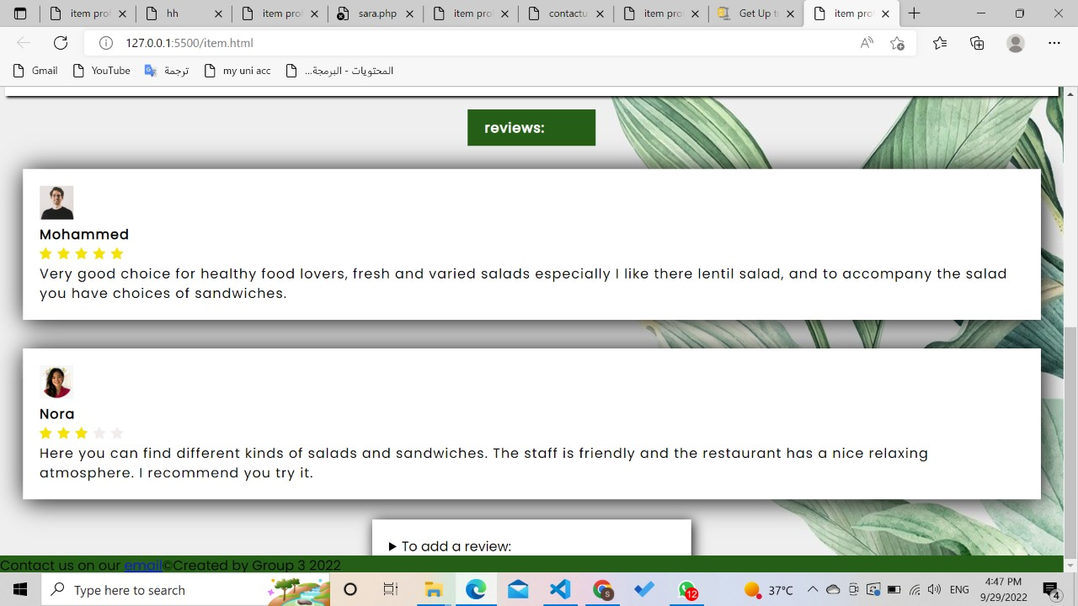

**If a client wants to add a new review they can click on "To add a review" and a text area will apeare for them to write their reviews and click"submite"to shere it.**

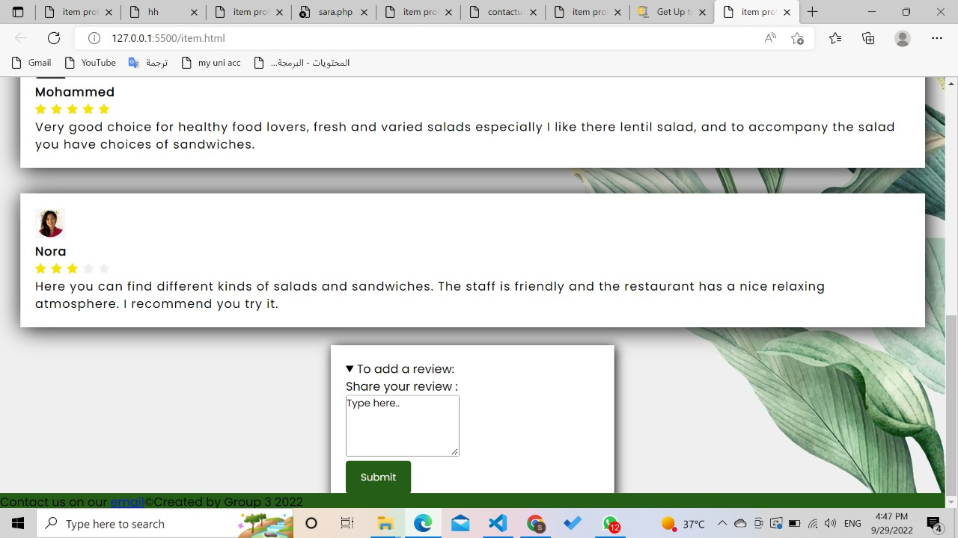

**The other items profile pages:**

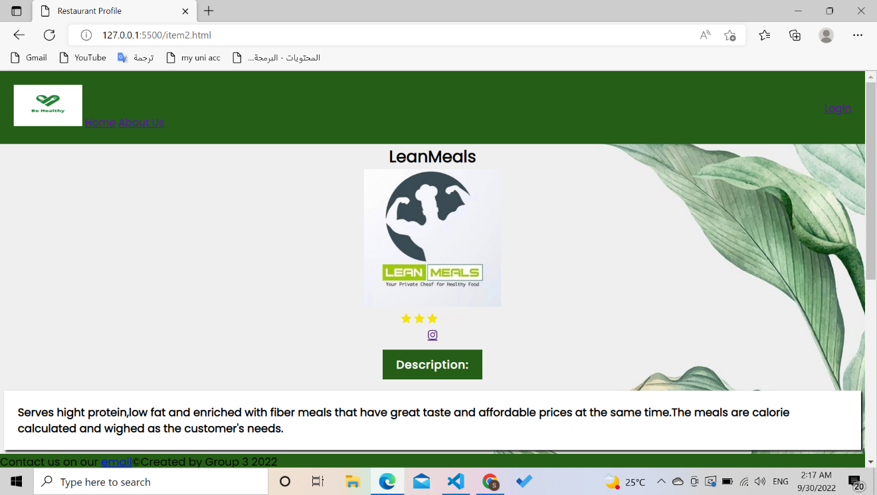

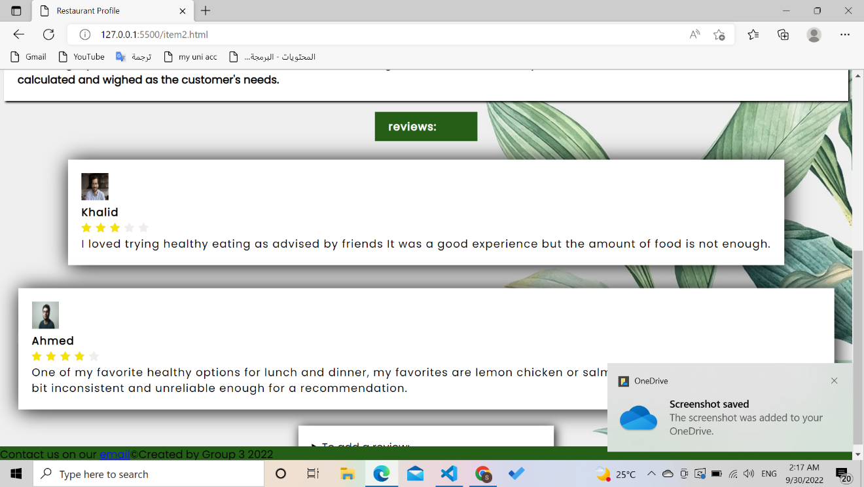

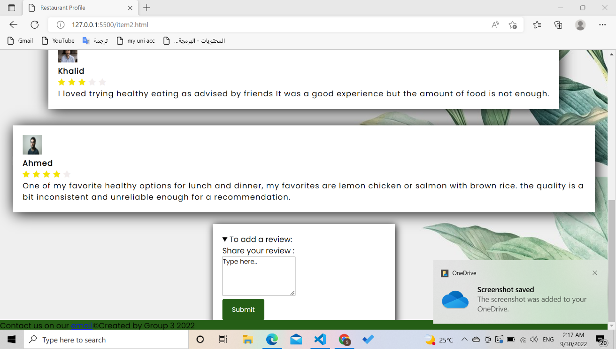

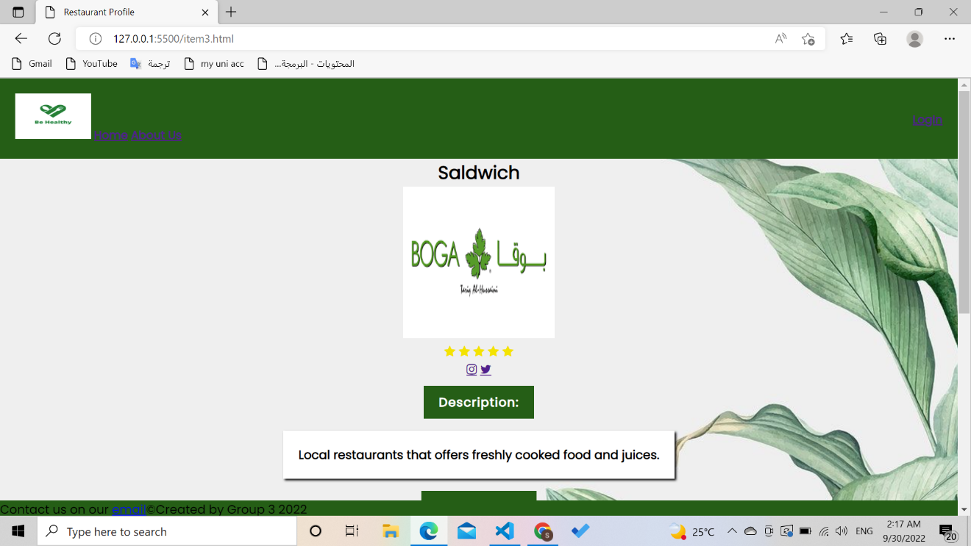

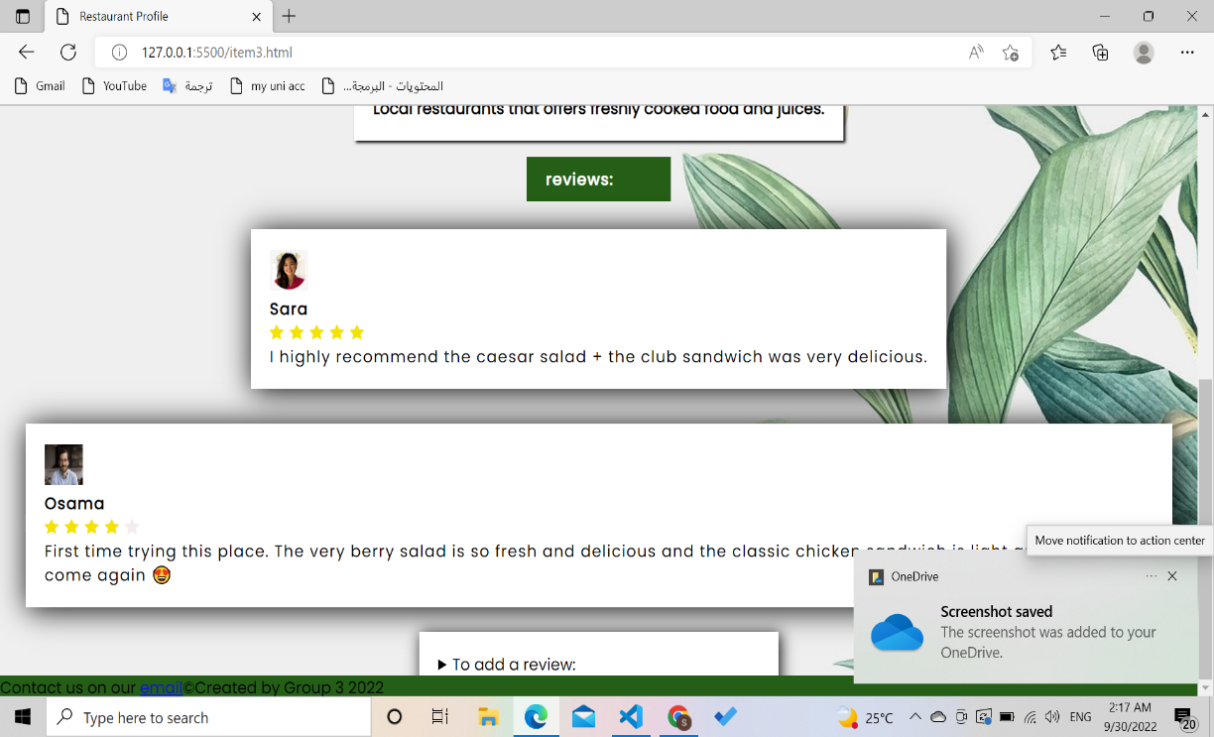

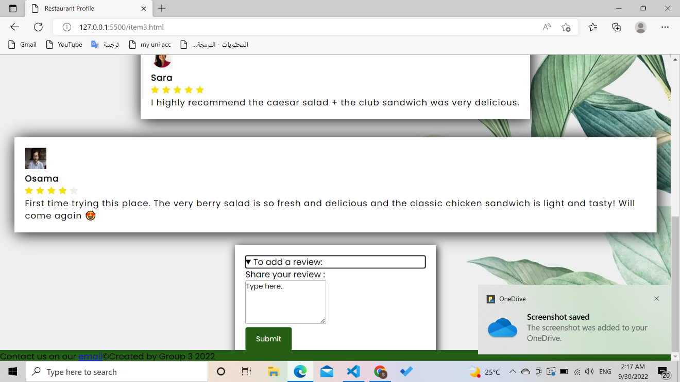

1. **Admin log-in page:**

**For the admin to log in, if the admin forgot their password they can click on "Forge password?" to go to reset password page.**

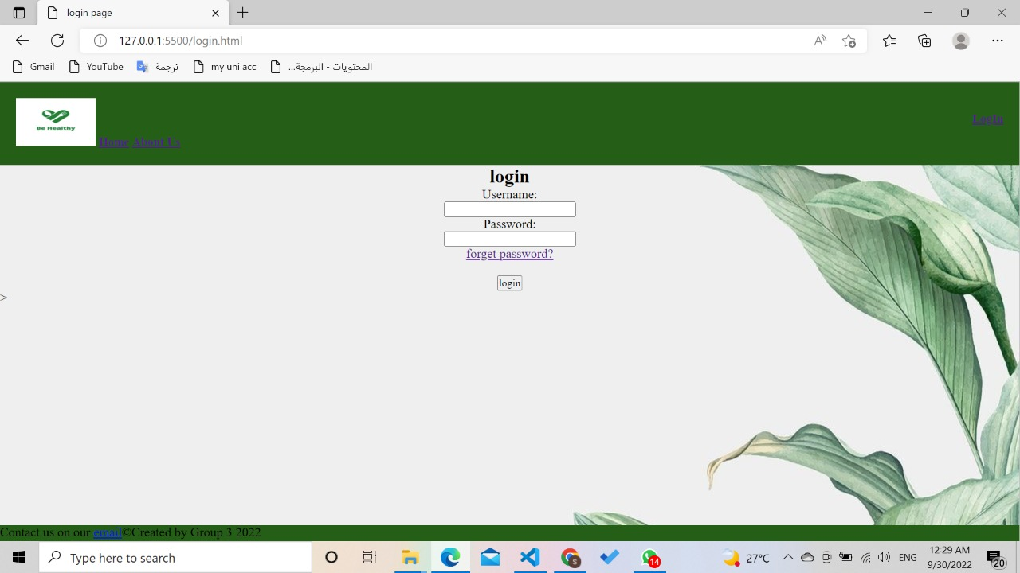

1. **Reset password page:**

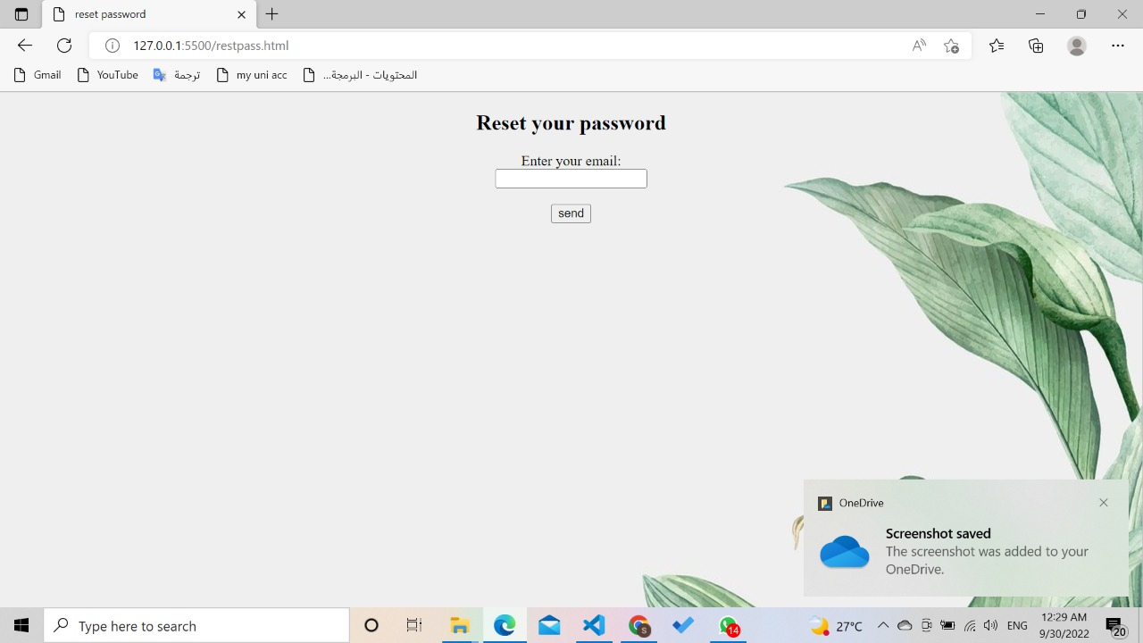

1. **The Admin Control Panel page:** 
   1. **Add Item page:**
   2. **Delete Item page:** contains a form that shows a list of available items, the admin selects a certain item then he/she can delete it.
   3. **Edit Item page:**

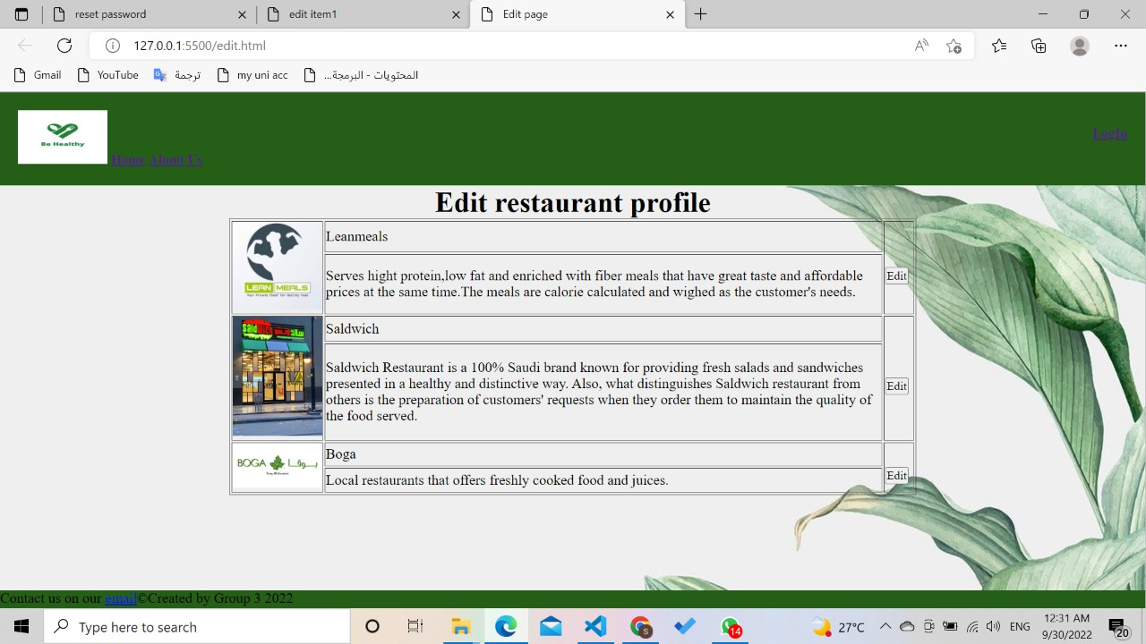

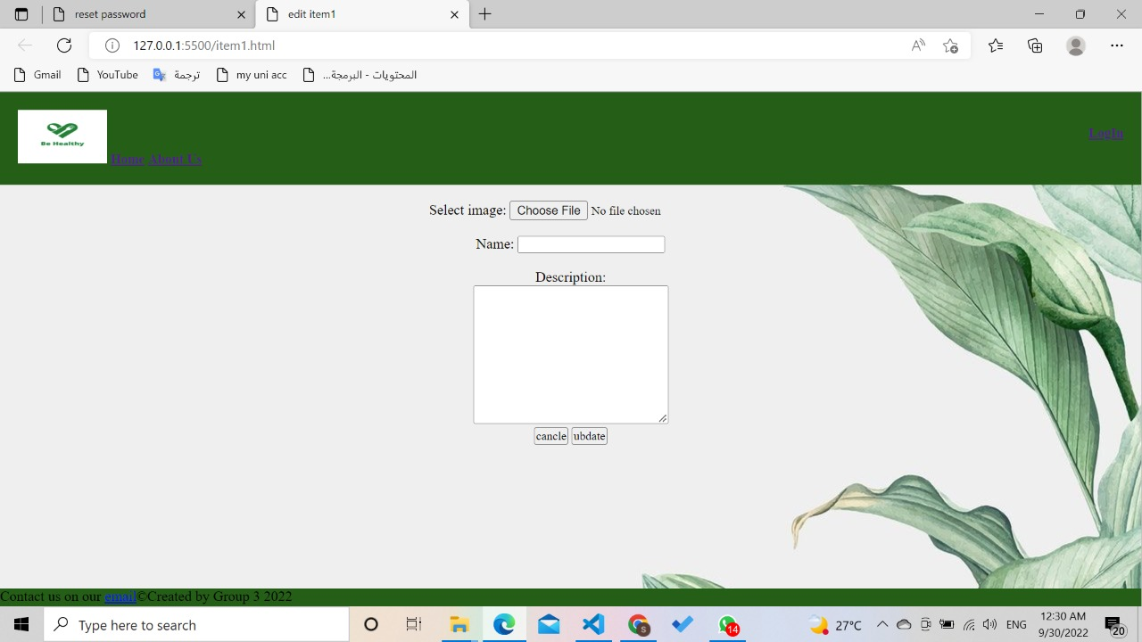

* **Wireframes**:

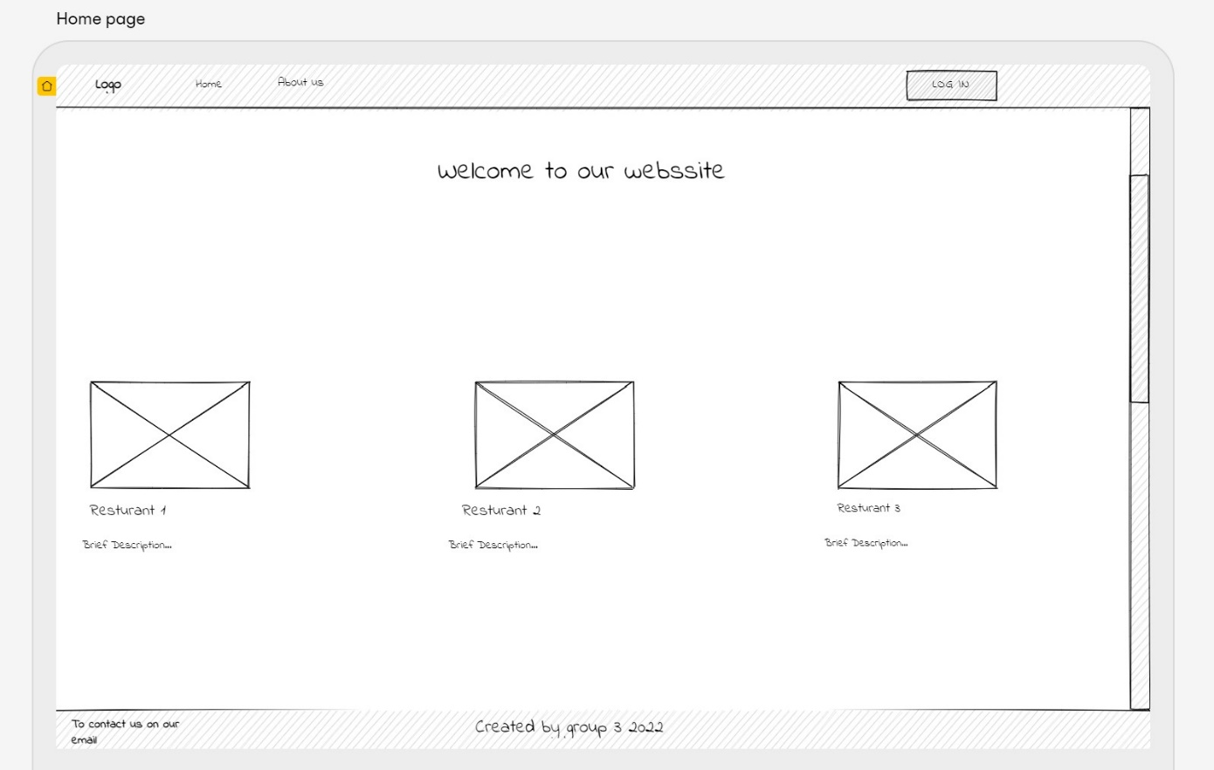

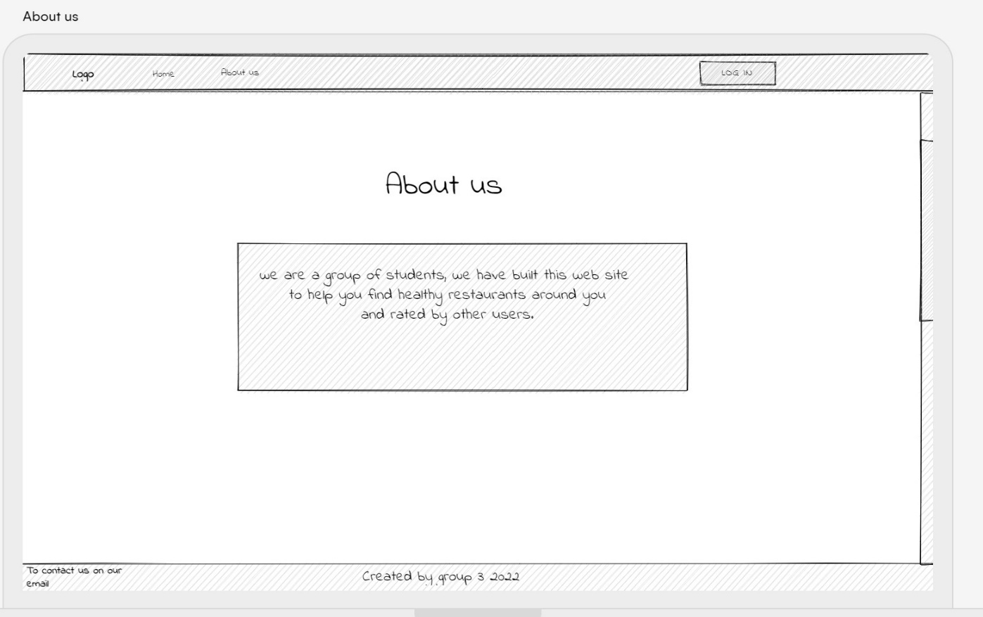

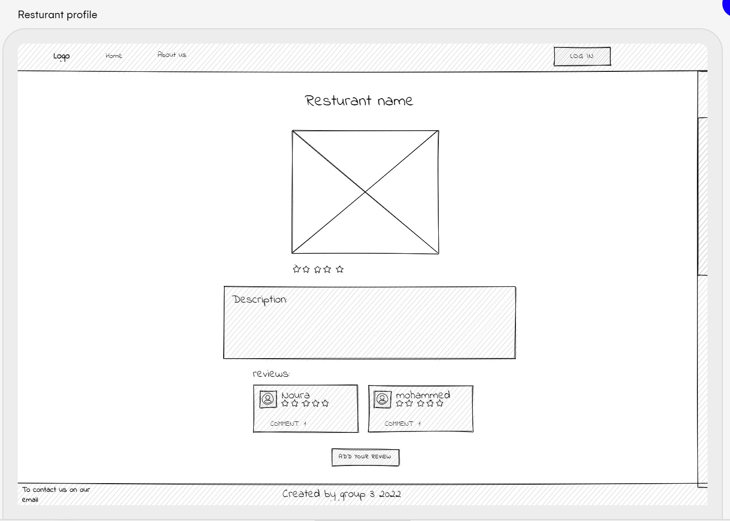

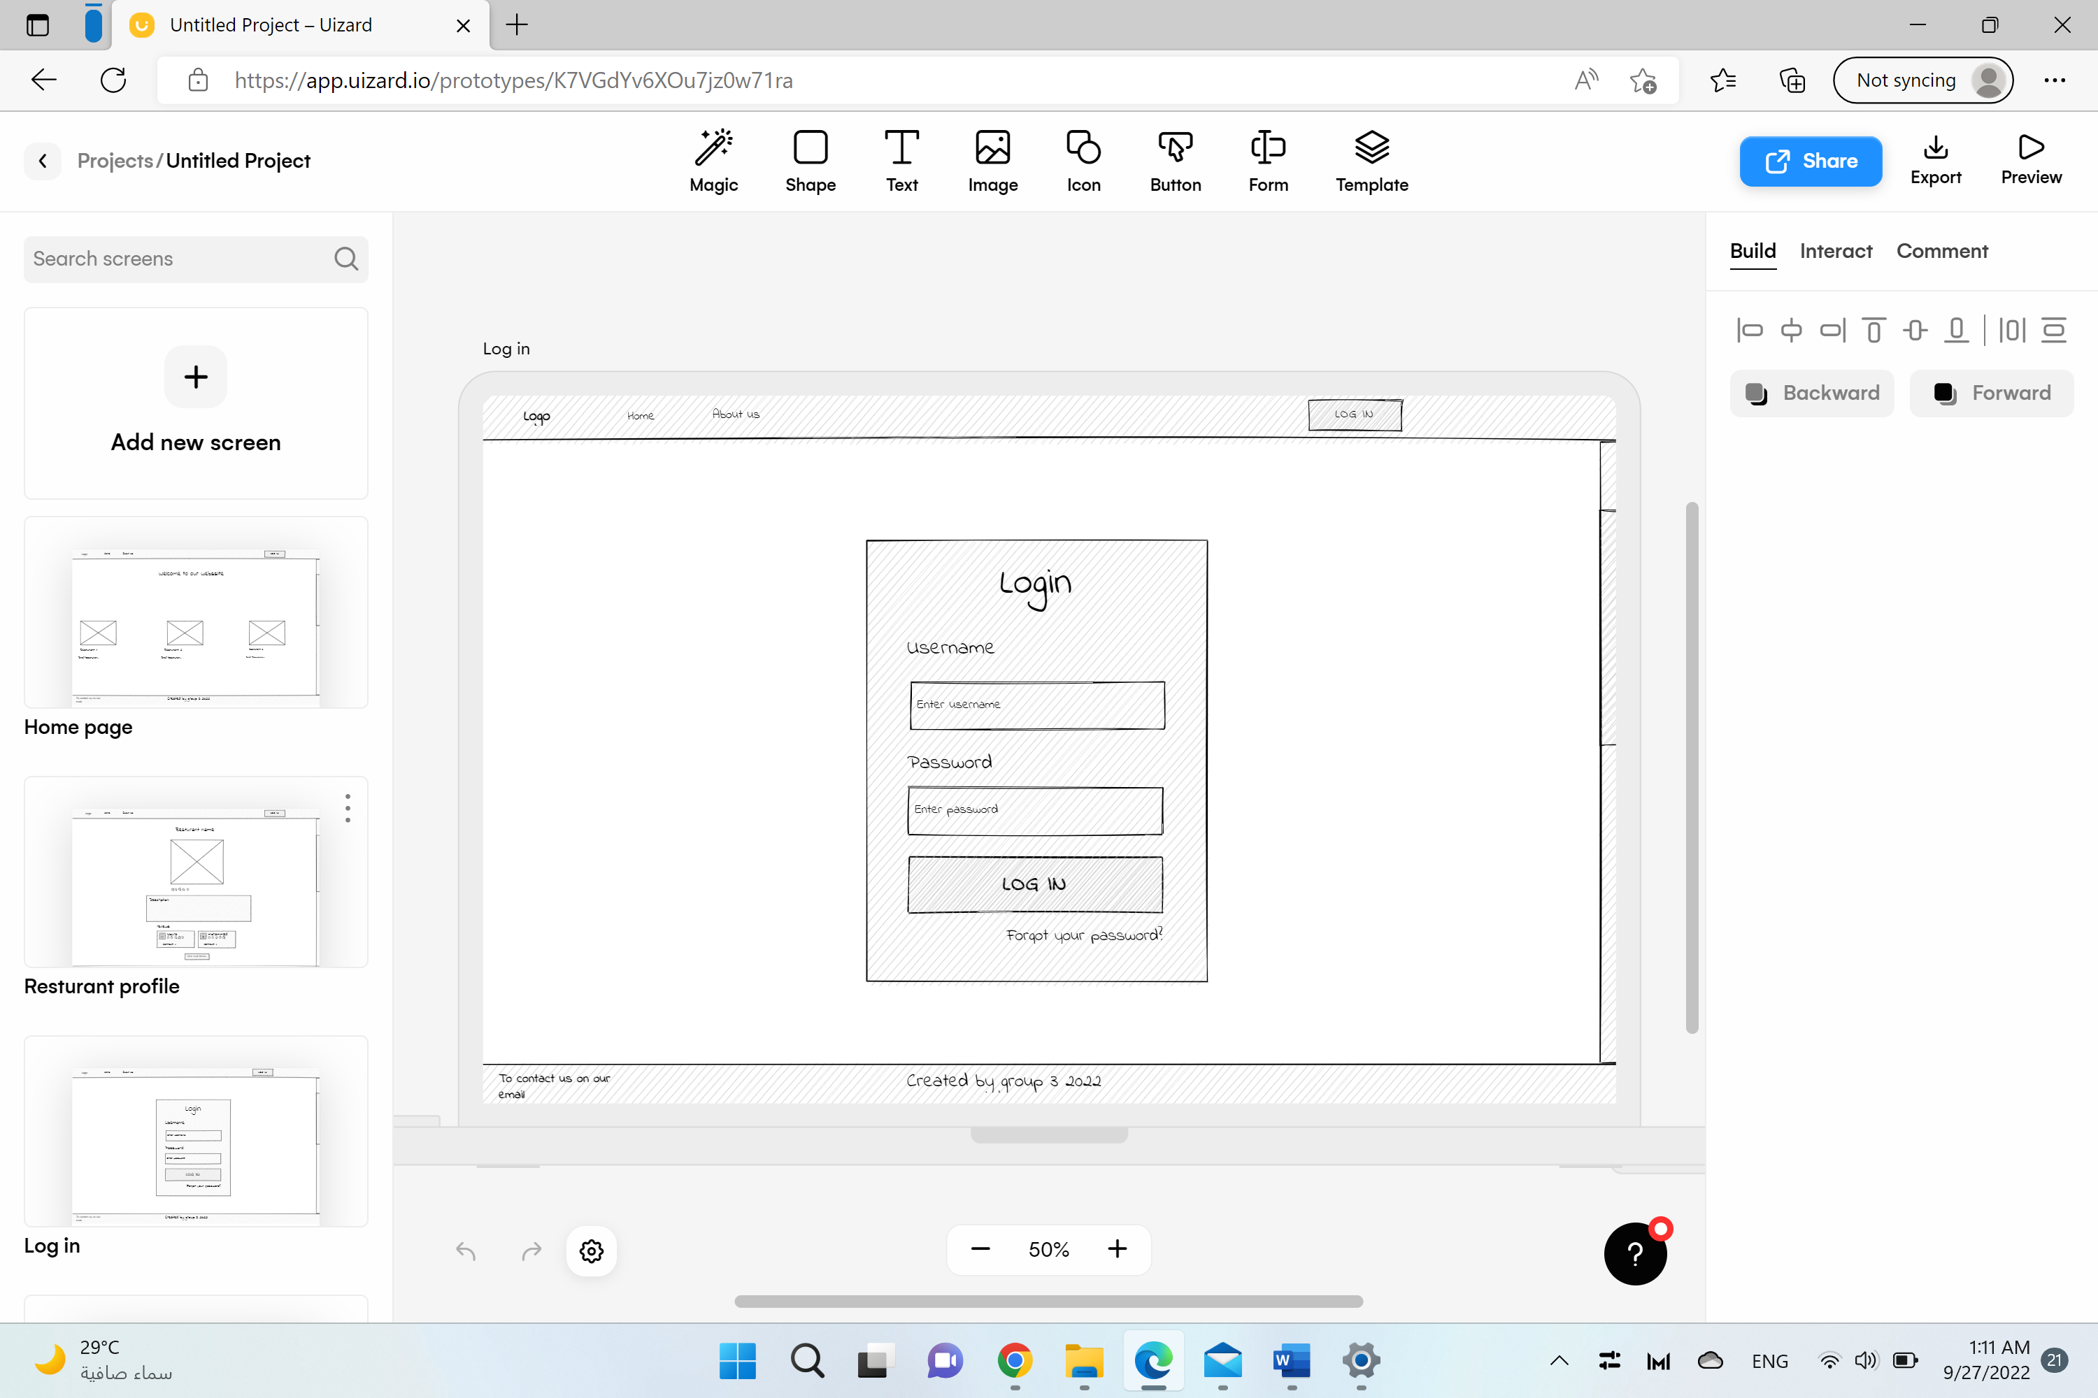

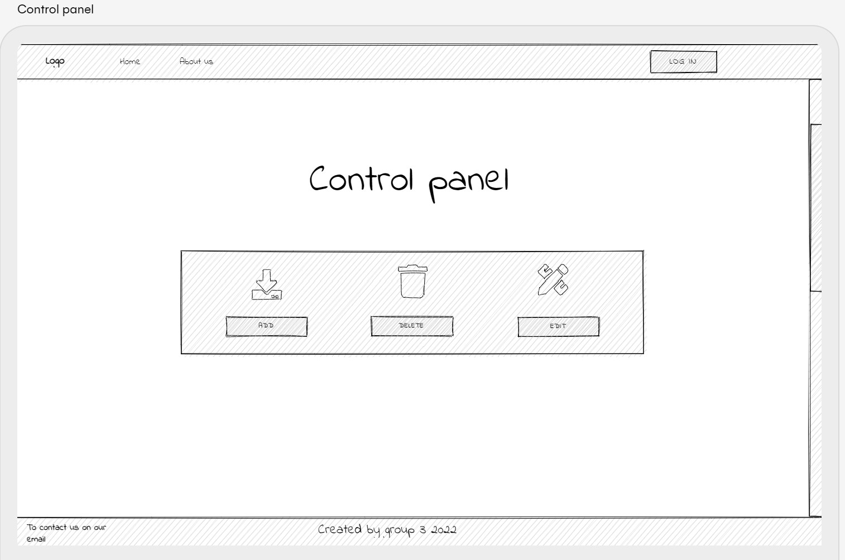

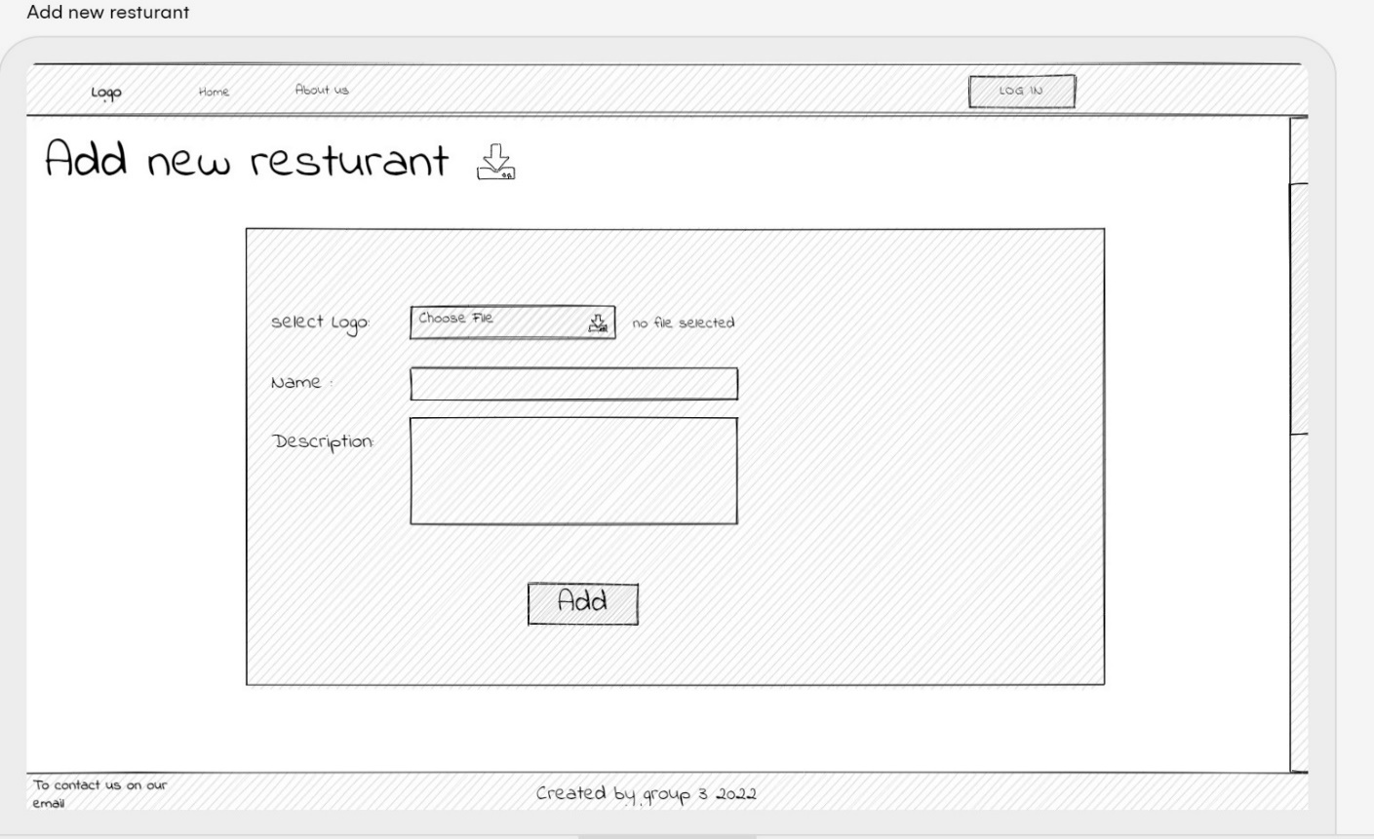

Delete page

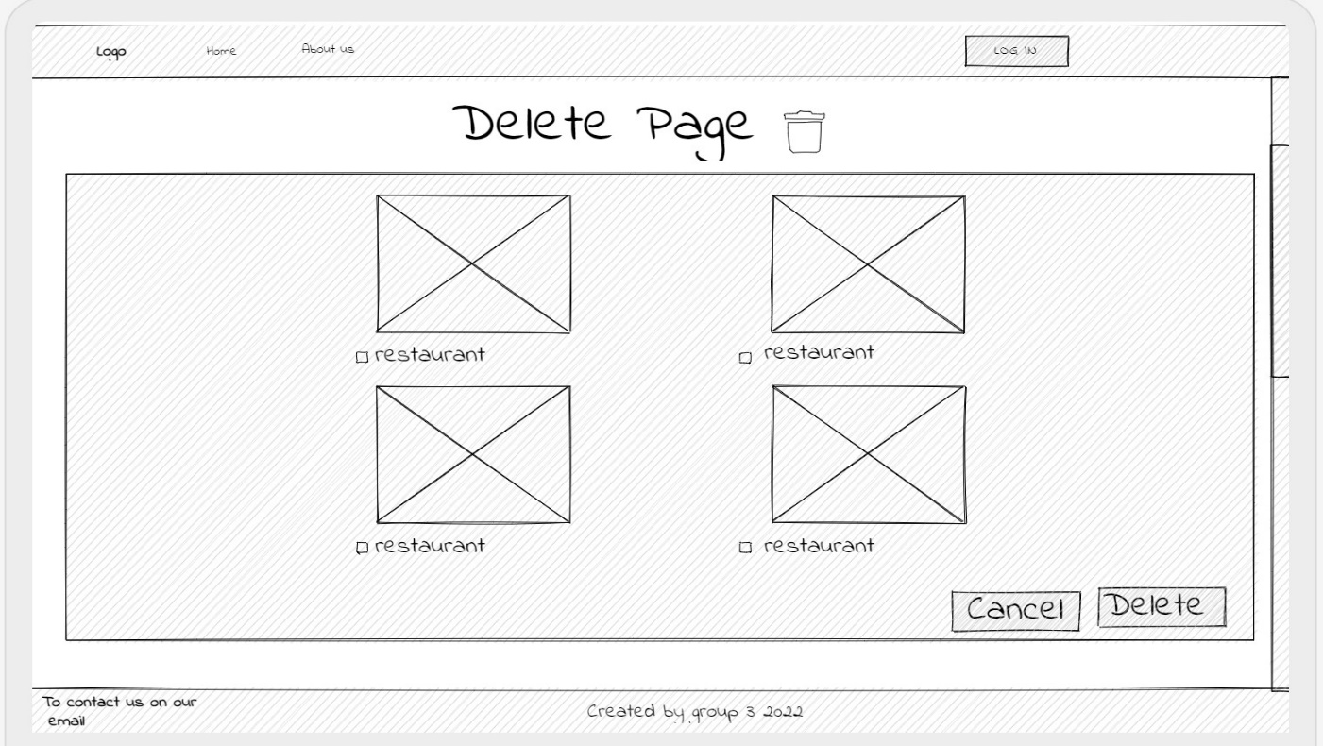

Edite restaurant page

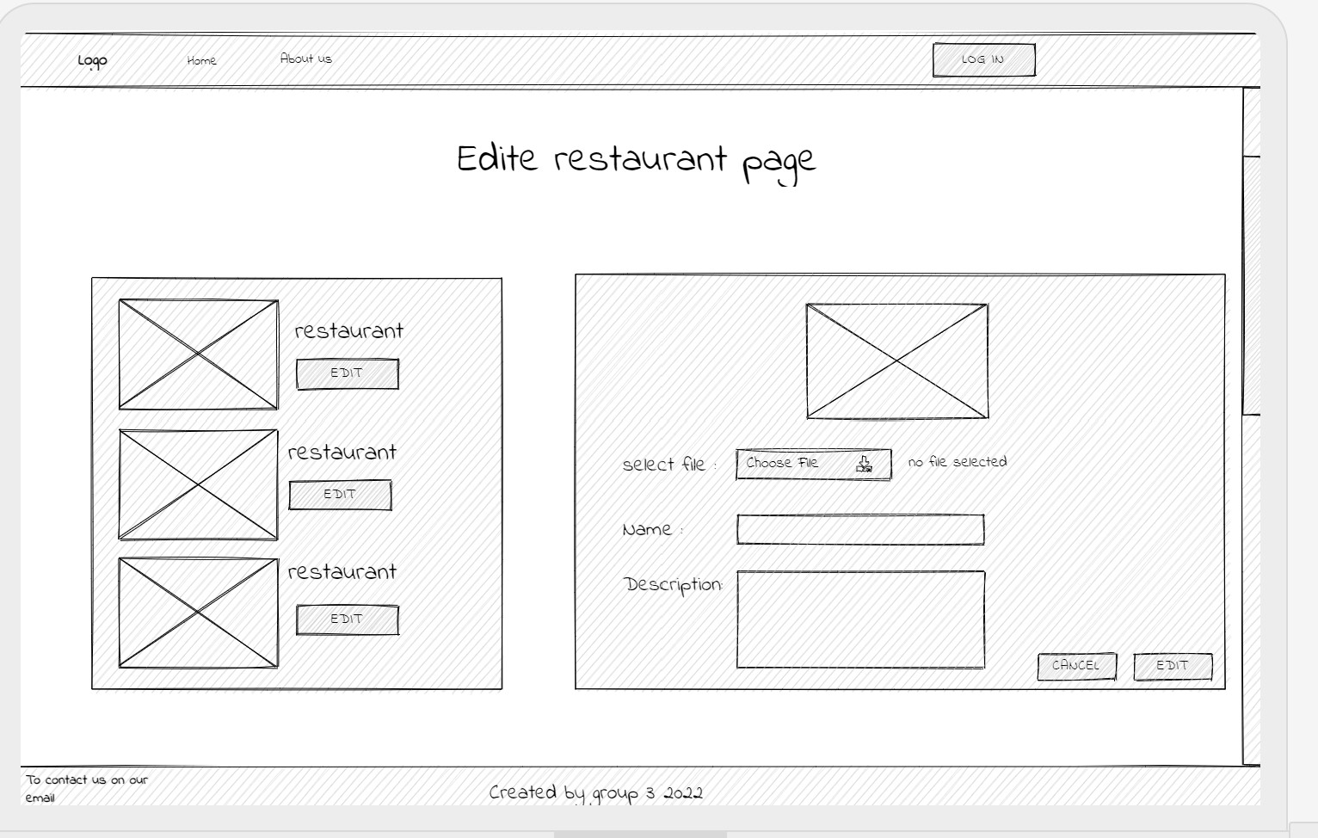

**Notes:**

* All your pages should use same or similar style, so that the pages look like they belong to the same website.
* You should have a consistent navigation, for example if you have a menu which links to different pages, the menu should appear in the same place in all pages, so that users can easily find the menu and be able to navigate to different pages.
* You should organize all the pages in a good structure.
* Use either an image map, or graphic images (buttons) for navigation links

**Deliverable:**

* A documentation print-out that contains all the above required points, including: Site’s topic, Site's goal, Site's audience, Competitive Analysis, Functional Requirements, Site map and wireframes + a compressed folder for the project source code.

**Submission:**

You should compress all your files for Phase 1 into a zip (.zip) file and name like "project_Phase1_<group-name>.zip, under "**IT390**" , Delivers on Thursday 29 Sep.